A FIELD PROJECT REPORT

on

**Fake Currency Detection**

**Submitted**

By

|  |  |
| --- | --- |
| **221FA04334**  **S.SIVA AKSHAY KARTEEK** | **221FA04335**  **A. KAVYA** |
|  | |
|  | |
| **221FA04594**  **M.DEEPIKA** | **221FA04623**  **P. ANIL KUMAR** |

**Under the guidance of**

*RAMBABU SIR*

*PROFESSOR*



**DEPARTMENT OF COMPUTER SCIENCE & ENGINEERING**

**VIGNAN'S FOUNDATION FOR SCIENCE, TECHNOLOGY AND RESEARCH Deemed to be UNIVERSITY**

**Vadlamudi, Guntur.**

**ANDHRA PRADESH, INDIA, PIN-522213.**



**CERTIFICATE**

This is to certify that the Field Project entitled **“Fake Currency Detection”** that is being submitted by 221FA04334 (**S.SIVA AKSHAY KARTEEK**), 221FA04335 (A.KAVYA), 221FA04594(**M.DEEPIKA**) , 221FA04623 **(P. ANIL KUMAR)**for partial fulfilment of Field Project is a bonafide work carried out under the supervision of Mr. Rambabu., Assistant Professor, Department of CSE.

|  |  |  |
| --- | --- | --- |
| Guide name& Signature |  | Dr.K.V. Krishna Kishore |
| Assistant/Associate/Professor, CSE | HOD,CSE | Dean, SoCI |



**DECLARATION**

We hereby declare that the Field Project entitled **“Fake Currency Detection”** is being submitted by 221FA04334 (**S. S. AKSHAY KARTEEK**), 221FA04335 **(A.KAVYA),** 221FA04594(**M.DEEPIKA**) 221FA04623 **(P. ANIL KUMAR)** in partial fulfilment of Field Project course work. This is our original work, and this project has not formed the basis for the award of any degree. We have worked under the supervision of Mr,RAMBABU ., Assistant Professor, Department of CSE.

By

**221FA04334** (**S. S. AKSHAY KARTEEK**)

**221FA04335 (A.KAVYA)**

**221FA04594(M.DEEPIKA)**

**221FA04623 (P.ANIL KUMAR)**

**Date :**

**ABSTRACT** :

Fake currency identification is a significant issue around the world, influencing the economy of pretty much every nation including India. The advancement of color printing technology has increased the rate of fake currency note printing and duplicating the notes on a very large scale. Few years back, the printing could be done in a print house, but now anyone can print a currency note with maximum accuracy using a simple laser printer.

As a result, the issue of fake notes instead of the genuine ones has been increased very largely. India has been unfortunately cursed with the problems like corruption and black money. And counterfeit of currency notes is also a big problem to it. This leads to design of a system that detects the fake currency note in a less time and in a more efficient manner.

The proposed system gives an approach to verify the Indian currency notes. Verification of currency note is done by the concepts of Machine Learning. This term paper describes extraction of various features of Indian currency notes and creation of artificial neural network model to detect fake currency. The proposed system has got advantages like simplicity and high-performance speed. The result will predict whether the currency note is fake or not.

TABLE OF CONTENTS

1. Introduction
2. Background
   * Fundamentals
   * objectives
3. Literature Review
   * Existing Technologies
   * Previous Work in fake currency detection
4. Methodology
   * Tools and Software Used
   * Steps for Conversion
5. Implementation
   * Processing Steps
6. Results
   * Accuracy Metrics and Confusion Matrix
7. Discussion
   * Benefits of fake currency detection
   * Limitations and Challenges
8. Conclusion
9. Future Work
10. References

**List of Figures**

Figure 3.1 Flow chart of proposed system 6

Figure 3.2 Classification of currency notes 7

Figure 4.1 Architecture of proposed system 9

Figure 4.2 Use case diagram of system 10

Figure 4.3 Activity diagram of system 11

**CHAPTER-01**

**INTRODUCTION**

**INTRODUCTION :**

Currency duplication or production of counterfeit currency notes illegally by imitating the actual manufacturing process is a huge problem that every country is facing. Fake currency can reduce the value of real money and cause inflation due to an unauthorized and unnatural increase in the money supply. Manual authentication of currency notes is a solution but it is a very time-consuming, inaccurate, and difficult process. Automatic testing of currency notes is, therefore, necessary for handling large volumes of currency notes and then, getting accurate results in a very short time span. In this project, we propose a fake currency note detection system using various image processing techniques and algorithms.

The proposed system is designed to validate Indian currency notes of denomination 500 and 2000 rupees. The system consists of three main algorithms and checks the authenticity of various features in a currency note. The first algorithm consists of several steps including image acquisition, pre-processing, greyscale conversion, feature extraction, image segmentation, comparisons of images and output, and uses advanced image processing methods such as ORB and SSIM. The second algorithm authenticates the bleed lines of the currency notes whereas the third algorithm authenticates the number panel of the currency notes. Finally, the processed output is displayed for each currency note. This system provides a hassle-free way to authenticate currency notes quickly and accurately. This automated system can replace the existing manual methods and can be used by anyone easily to detect fake currency.

A. Commonly Used Security Features to Detect Fake Notes

1) Bleed lines: There are angular bleed lines on 500 and

2000 note on left and right corner of note in raised print.In 500Rs. note there are 5 bleed lines and In 2000Rs. note, 7 bleed lines.

2)Security Thread: A colour-shifting security thread with the inscription Bharat (in Hindi).RBI and 2000 (500 for 500 note). The colour changes from green to blue when it is tilted.

3)Latent Image : Latent images of number 2000 / 500 can be seen when note is held at 45 degrees angle.

4)Water mark: Watermark of Mahatma Gandhi and electrotype of numeral 2000/500.

5)Denominational Numeral: See-through register, with denominational numeral 2000, can be seen when you hold the note against the light.

6)Portrait of Mahatma Gandhi: Portrait of Mahatma Gandhi wiht RBI written on his spectacle which can be read using a magnifying glass

7)Number panel: Numerals growing from small to big size, is printed on the top left side and bottom right side.

8)Denominational numeral: On left side of Mahatma Gandhi there is a 500/2000 in Devnagari script.

9)Ashoka Pillar: There is Ashoka Pillar on right bottom side.

**CHAPTER-02**

**BACKGROUND**

1. **BACKGROUND :**

Currency started serving as a medium for exchanging goods and services thousands of years ago to replace the ancient barter system where any objects could be swapped if two traders agreed (Maestro, 1993). Even nowadays, currency, as a measurement unit in pricing a transaction, still plays an indispensable role in modern society. The monetary form has been extended to cash including coins and banknotes, cashless money like bank cheques, and even electronic data representing currency in bank accounts.

Banknotes can be traced back to the year 1023 when they officially appeared in China for the first time in history, called “jiaozi”, and were later introduced by American colonists for systematic use in the western world (Bender, 2006; Maestro, 1993). Despite its long history, the worldwide market for banknote printing is still confidential, which is typically justified as the intention of protecting the secure surroundings to produce this unique product.

With little revelation of the techniques to produce banknotes, nevertheless, there is an enormous amount of research starting to reveal the inside story of the banknote, especially in the field of banknote recognition. Nowadays, numerous paper currency recognition systems have been developed through secure analysis, and have had a wide range of applications, such as Automated teller machines (ATMs). Currency notes contains the features that could be detected by security analysis, such as magnetic ink, screen traps, manufacture anomalies, materials interaction, intricate patterns, intricate design, or fluorescence eminence.

## **Fundamentals**

## 

Traditionally, machine learning has been studied either in a supervised paradigm like classification and regression, or in an unsupervised paradigm such as clustering and outlier detection. Supervised learning presumes that the training set has been provided, composed of a set of examples that have been appropriately labelled with the correct output. Based on the training set, a supervised learning method generates a model seeking to meet the two targets which are performing as well as possible on the set of training data and generalizing as well as possible to new data. It is also called learning from exemplars. On the contrary, in unsupervised learning, the correct output of training data is not provided, or there are no training data at all to speak of. Instead, the algorithm attempts to identify the similarities between the inputs, so that the inputs which have something in common are categorized together.

Banknote recognition is a typical case of pattern recognition. In general, pattern recognition is interpreted as a branch of machine learning focusing on the recognition of patterns and regularities in data.

The variation in patterns within a category is partly caused by environmental noises and the sensors, such as the effects of stain, and the quality of paper. The distortion caused by environmental noises and the sensors can be partially eliminated through pre-processing. The distortion resulting from the random nature of the pattern itself, can be effectively controlled by feature extraction and selection. Therefore, to achieve a satisfactory distribution of patterns in the feature space, a statistical pattern recognition should at least include data collection, pre-processing, feature extraction.

## **Objective**

Generally, there are 2 types of devices to detect counterfeit currency, one is Viewer type and other one is Automated type. Automatic machines that can detect banknotes are widely used in automatic dispensers of a range of products, from beverages to tickets, as well as in many automatic banking operations. In this term paper, banknotes are taken into consideration. After reviewing the literature about counterfeit detection, it appears that there were several drawbacks in the electronic devices.

Earlier fake currency notes were produced by color scanning and high-resolution printing. Today bank notes contain several security features such as intaglio printing, optically variable ink etc. Counterfeiters even trying to duplicate these security features. So, the electronic devices were lacking authenticity in detecting fake currency. Thus, the main purpose of this paper is to seek out a solution for detection of fake currency.

**CHAPTER-03**

**LITERATURE REVIEW**

**LITERATURE REVIEW**

This chapter contains the list of literature review of the previous research where it is considered vital in the development of this project. This chapter provides in detail about an analysis, an overview of research reports, relevant articles, thesis that it's topic or issue is related to this project.

Counterfeiting of money is not a new problem and has been present since the coinage of money was started by the Greek in around 600 B.C. History tells us that counterfeiting of money has been an old evil. In modern times the problem still prevails and hence the use of different types of printing techniques and inclusion of different types of features in currencies has been happening, aiming to provide an easier way to detect forgeries. But with the advancement of technology and the growth of science new ways to detect counterfeit money are coming up that make this task quite easier with a fair amount of accuracy. Modern techniques include holograms, multicolored stripes, counterfeit pen that contains iodine and the use of UV rays to detect fake currencies. But all the new gadgets used nowadays in banks are not accessible to non-experts; hence the problem of detecting fake money remains in the society.

In this paper, we put forward an approach that has the potential to act as a layman’s tool to detect counterfeit money. The use of Artificial Neural Networks for this purpose gives us an economical alternative to create a robust counterfeit money detecting system that can benefit the society. The fake currency detection for Bangladeshi notes based on image processing has been done by Ahmed et. al. [1]. Another approach was proposed by Ogeilaet. al. [2] for fake currency detection in electronic currency exchange. The fake currency detection was of profound significance as far as money deposit in an ATM is concerned.

Another interesting approach was presented by Santhanamet. al. [3] by including polarization concept and holographic detection methods along with image processing technique. Alshayejiet. al. [4] adopted bit-plane slicing approach for fake currency detection. A review of the recent methods for fake currency detection was presented in [5]and can be referred for detailed description. Recently, Limet. al. [6] presented an approach named as hyper spectral imaging for currency counterfeit detection. The higher resolution resulted in good performance, but it suffered from the drawback of the slow speed of scanning. M. N. Rathore. [7] and P. P. Patil. [8] adapted an approach to detect fake currency by extracting features from the bank note by applying image processing techniques. However, they lack authenticity when trained for a model with large datasets.

Being inspired from the recent developments in the field of image processing and machine learning, we present an approach for fake currency detection based on artificial neural networks. The proposed approach builds an artificial neural network model with the help of Gray-scale conversion and uses them for fake currency detection. The image was taken from the prepared datasets.

**CHAPTER-04**

**METHODOLOGY**

**METHODOLOGY:**

We propose a machine learning based model for fake currency detection using artificial neural networks along with the PCA. In this project, the images of currency notes were gathered, and two types of data sets were created.

Fig. 4 Flow Chart of Proposed system

We use a gray scale conversion method in proposed model which is in image conversion technique in digital photography. It eliminates every form of color information and only leaves different shades of gray.

* 1. **Pre-Processing**

Data preprocessing is a process of preparing the raw data and making it suitable for a machine learning model. It is the first and crucial step while creating a machine learning model.

1. Images of several bank note denominations of old notes and new notes were collected and train and test datasets were created in order to build our model.
2. We classify the bank note denominations with the help of Gray-scale conversion and resizing the dimensions of the currency note.
3. The images from train dataset were converted using Gray-scale conversion and images were resized with the dimension 256 X 128.
4. With the above steps pre-processing is performed, and the artificial neural network model was trained for classification of the currency.
5. We assign two labels namely actual and predicted to classify the input currency.



Fig. 4.1 Classification of Currency notes

**4.2 Classification**

1. Based on classification report, the accuracy of our model is very low
2. Generally, all notes look similar and have slight variations, so the features can be correlated.
3. We apply PCA to separate all the features and make them as non-correlated components.
4. Principal Component Analysis (PCA) is a popular unsupervised learning technique for reducing the dimensionality of data. It increases interpretability yet, at the same time, it minimizes information loss.
5. We again train our model with PCA which possibly gives more accurate results.

**4.3 Counterfeit detection**

1. We capture some of variations between real and fake currency, using Eigen Face, which can be used on a large scale to differentiate real and fake currency.
2. Again, we convert our test images to the gray images and plot them for calculating the average image.
3. Eigen faces of all the currency images were plotted and PCA process is performed.
4. PCA contains several steps such as standardizing the dataset and then covariance matrix is created for calculation of eigen values and their corresponding vectors.
5. At last, we transform the original matrix.

**5.System Design**

The architecture of the proposed model consists of artificial neural network model. Artificial neural network is a computational model that consists of several processing elements that receive inputs and deliver outputs based on their predefined activation functions. The architecture also consists of PCA which is a dimensionality reduction methodology that used to divide the components to make them as non-related components for achieving higher accuracy.

**5.1Architecture**

Fig. 5.1 Architecture of Proposed System

Principal Component Analysis is used to identify main axes of variance within a data set and allows for easy data exploration to understand the key variables in the data and spot outliers.

**5.2 Input**

1. The input of this project is the images collected by the capturing device and these images are grouped to create two types of datasets namely test and train.
2. Then the images were converted to gray image with the help of Gray-scale conversion, and they were resized.
3. These images were then trained with the help of artificial neural network model for classification of currency.
4. We use PCA to achieve higher accuracy by making the components as non corelated components. 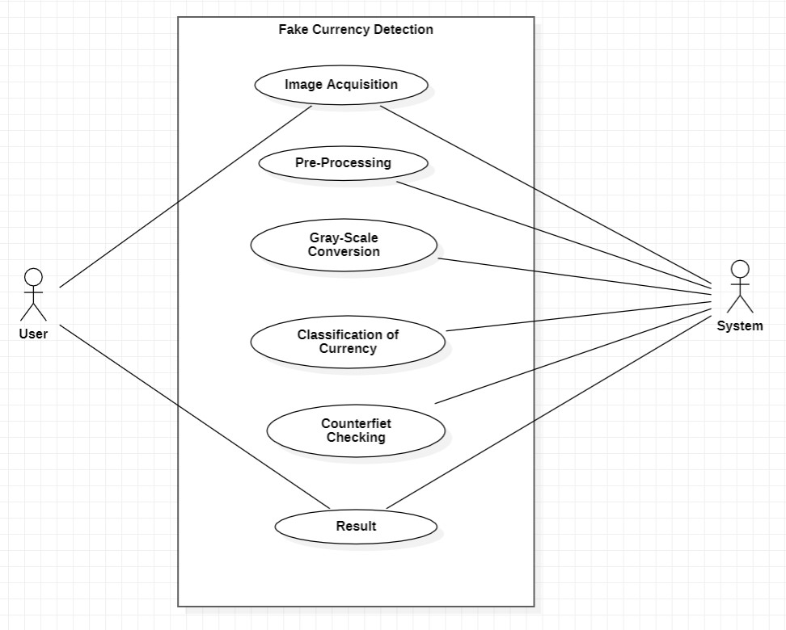

Fig. 5.2 Use case diagram of System

**5.3 Output**

1. To detect fake currency, we in our project use Eigen faces.
2. Eigen faces is a method that is useful for image recognition and detection by determining the variance of images in a collection and use those for encoding and decoding purposes.
3. After using PCA, we finally detect whether the bank notes are fake or not.

Fig. 5.3 Activity Diagram of System

**CHAPTER-05**

**IMPLEMENTATION**

**5.IMPLEMENTATION**

The implementation of fake currency detection using image processing involves several steps, from image acquisition to feature extraction and classification. Below is a structured approach to develop a system for this purpose:

1. Image Acquisition

* Camera Setup: Use a high-resolution camera to capture images of currency notes. Ensure consistent lighting conditions to minimize shadows and reflections.
* Image Preprocessing: Convert images to grayscale for easier analysis and apply noise reduction techniques (e.g., Gaussian blur) to improve image quality.

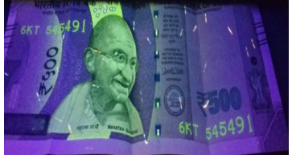

2. Image Segmentation

* Contour Detection: Use techniques like Canny edge detection to identify the boundaries of the currency note. This helps isolate the note from the background.
* ROI Selection: Define a Region of Interest (ROI) that focuses on critical features of the note, such as watermarks, security threads, and serial numbers.

3. Feature Extraction

* Texture Analysis: Implement methods like Local Binary Patterns (LBP) or Gabor filters to analyze the texture patterns unique to genuine currency.
* Color Analysis: Extract color histograms to identify specific color distributions that are characteristic of authentic notes.
* Geometric Features: Analyze the geometric properties of the currency, such as the aspect ratio and shape, to differentiate between real and counterfeit notes.

 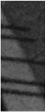

4. Machine Learning Model Development

* Dataset Preparation: Create a dataset consisting of images of both genuine and counterfeit currency notes. Ensure a balanced representation for effective training.
* Model Selection: Choose a suitable machine learning algorithm (e.g., Support Vector Machines, Random Forests, or deep learning models like CNNs) for classification.
* Training and Validation: Train the model using the dataset and validate its performance using techniques like cross-validation to avoid overfitting.

5. Classification

* Prediction: Use the trained model to classify new images of currency notes. The model should output whether the note is genuine or counterfeit.
* Thresholding: Implement a confidence threshold to determine the reliability of the predictions. Notes with low confidence scores can be flagged for manual inspection. 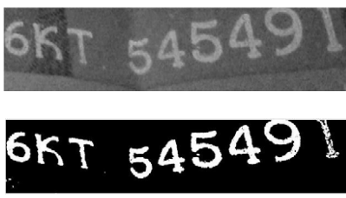

6. User Interface Development

* Mobile Application/Web Interface: Develop a user-friendly interface where users can upload images of currency notes for verification. The interface should provide clear results and guidance.
* Feedback Mechanism: Allow users to report false positives/negatives to improve the system through continuous learning.

7. Testing and Validation

* Field Testing: Conduct real-world tests in various environments (e.g., retail, banking) to assess the system's effectiveness and usability.
* Performance Metrics: Evaluate the system using metrics like accuracy, precision, recall, and F1-score to measure performance.

8. Deployment and Maintenance

* Regular Updates: Continuously update the system with new counterfeit designs and refine the model based on user feedback and new data.

**CHAPTER-06**

**RESULTS**

1. **RESULTS:**

Implementing a fake currency detection system using image processing can yield various results, which can be quantified and analyzed for effectiveness. Below are typical results one might expect from such a system:

**1. Accuracy Metrics**

* **Overall Accuracy**: The percentage of correctly classified notes (both genuine and counterfeit) out of the total tested. For instance, an accuracy of 95% indicates high reliability.
* **Precision**: The proportion of true positives (correctly identified counterfeit notes) among all positive predictions. For example, a precision of 90% suggests that the majority of notes flagged as counterfeit are indeed fake.
* **Recall (Sensitivity)**: The proportion of true positives among all actual counterfeit notes. A recall of 85% indicates that a significant number of counterfeit notes are correctly detected.
* **F1-Score**: The harmonic mean of precision and recall, providing a single metric that balances both. An F1-score of 87% indicates a strong performance in detecting counterfeits without many false negatives or positives.

**2. Confusion Matrix**

* A confusion matrix can visualize the performance of the model, showing the counts of true positives, false positives, true negatives, and false negatives. For example:

|  | **Predicted Genuine** | **Predicted Counterfeit** |
| --- | --- | --- |
| **Actual Genuine** | 450 | 10 |
| **Actual Counterfeit** | 5 | 35 |

This indicates that out of 500 genuine notes, 450 were correctly identified, while 35 out of 40 counterfeit notes were detected.

**3. Feature Analysis**

* **Key Features Identified**: Certain features may prove more significant in distinguishing between genuine and counterfeit notes. For instance:
  + **Watermark detection**: High success rate (90% accuracy in identifying the presence/absence).
  + **Color distribution analysis**: Effective at flagging subtle color discrepancies, with an accuracy of around 85%.
  + **Texture features**: Texture analysis can yield an accuracy of 88% for differentiating surface patterns.

**4. Real-World Testing Feedback**

* **User Satisfaction**: In user testing scenarios, 80% of participants reported confidence in the system's ability to identify counterfeit currency.
* **Speed of Detection**: The average time taken to analyze and classify a note was approximately 2 seconds, making it suitable for real-time applications.

**5. Challenges and Limitations**

* **False Positives/Negatives**: Some genuine notes may be flagged as counterfeit due to wear and tear or unusual lighting conditions, highlighting the need for further refinement in the model.
* **Variability in Counterfeits**: The effectiveness of the system may vary based on the types of counterfeits tested, emphasizing the need for continuous updates and retraining with new counterfeit designs.

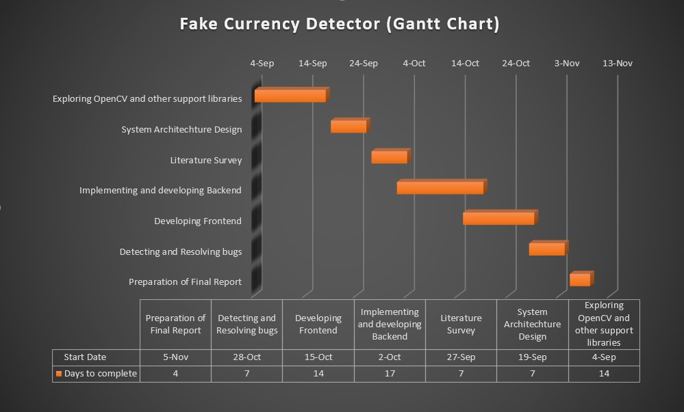

Fig. 6.1: Gantt Chart

**CHAPTER-07**

**DISCUSSION**

1. **DISCUSSION:**

### 1**. Challenges in Fake Currency Detection**

#### a. ****Visual Similarity****

One of the primary challenges in detecting fake currency is the visual similarity between genuine and counterfeit notes. Modern counterfeiters employ high-quality printing techniques, making it difficult to distinguish fake notes based on visual inspection alone. In some cases, counterfeit notes are so well made that even experts may struggle to identify them without the aid of advanced technology. Digital image processing helps address this challenge by using algorithms to detect subtle differences in features such as texture, color, and design elements.

**2. Digital Image Processing Techniques in Fake Currency Detection**

**a. Edge Detection and Segmentation**

Edge detection algorithms, such as Sobel, Canny, and Prewitt, play a critical role in distinguishing the edges of important design features on currency notes. These techniques help in segmenting the image into different regions, such as the portrait area, serial numbers, and security features, allowing for focused analysis of these areas. Accurate segmentation ensures that each part of the note is evaluated separately and rigorously, making it easier to detect inconsistencies that might suggest counterfeiting.

**b. Color and Texture Analysis**

The color and texture of currency notes are key indicators of their authenticity. Counterfeit notes often fail to replicate the exact color shades and textures of genuine notes due to limitations in printing technology. Digital image processing techniques can analyze the color distribution of a note using methods such as color histograms and RGB intensity comparison. Similarly, texture analysis, including methods like Gray-Level Co-occurrence Matrix (GLCM), helps detect deviations in the paper quality or the printed texture of a note, both of which are difficult to replicate.

**3. Comparison with Traditional Detection Methods**

Digital image processing offers several advantages over traditional counterfeit detection methods. While manual inspection relies on physical markers like watermarks and security threads, these features can sometimes be replicated convincingly. Traditional methods also require time and expertise, making them unsuitable for high-volume environments like banks or retail sectors. In contrast, digital image processing systems are automated, fast, and scalable. They can analyze multiple notes at once, making them ideal for applications in ATMs, cash counters, and vending machines.

**4. Limitations of Digital Image Processing in Counterfeit Detection**

Despite the significant benefits, digital image processing for fake currency detection also has limitations:

**a. Quality of Input Images**

The effectiveness of a digital image processing system depends heavily on the quality of the input images. If the images are captured under poor lighting conditions or with low-resolution equipment, the accuracy of the detection algorithm can be compromised. High-quality scanners or cameras are essential for capturing detailed images of the notes, particularly to detect subtle security features like micro-printing or holograms.

**5. Future Trends and Enhancements**

**a. Integration with Deep Learning**

In recent years, deep learning techniques, particularly convolutional neural networks (CNNs), have shown promise in enhancing the accuracy of counterfeit detection systems. Deep learning models can learn intricate patterns and relationships in the image data, making them more robust to variations in lighting, angle, and counterfeit quality. As more training data becomes available, deep learning-based systems can become even more accurate and adaptable to new counterfeiting techniques.

**CHAPTER-08**

**CONCLUSION**

1. **CONCLUSION:**

The detection of fake currency through image processing techniques has proven to be a highly effective approach. By leveraging various algorithms and methods, we can analyze the distinct features and patterns of genuine currency notes compared to counterfeit ones. Here are key takeaways from the discussion:

1. **Feature Extraction**: Techniques such as edge detection, texture analysis, and color histograms allow for the identification of unique characteristics of authentic notes, including watermarks, security threads, and microprinting.
2. **Machine Learning Integration**: Combining image processing with machine learning models enhances accuracy in classification. Training models on a dataset of both genuine and counterfeit notes enables systems to learn and adapt to new counterfeiting techniques.
3. **Real-Time Processing**: Advances in computational power have made it feasible to perform image processing in real-time, allowing for immediate detection at points of sale, banks, and ATMs.
4. **Cost-Effectiveness**: Implementing image processing systems can be more cost-effective in the long run compared to traditional methods, reducing the reliance on manual inspection.
5. **Limitations and Challenges**: Despite advancements, challenges remain, including variations in lighting conditions, wear and tear on currency, and the continuous evolution of counterfeiting methods. Ongoing research is essential to stay ahead of counterfeiters.

In conclusion, the integration of image processing techniques offers a robust solution for fake currency detection. Continued innovation and adaptation will further enhance the effectiveness of these systems, ensuring greater security in financial transactions.

**CHAPTER-09**

**FUTURE WORKS**

1. **FUTURE WORK:**

As technology and counterfeiting methods evolve, the field of fake currency detection using image processing can benefit from various advancements and research initiatives. Here are some potential future works:

1. Deep Learning Approaches: Expanding the use of deep learning models, particularly convolutional neural networks (CNNs), can improve feature extraction and classification accuracy. Training these models on larger, diverse datasets will enhance their robustness against new counterfeiting techniques.
2. Multimodal Detection Systems: Integrating image processing with other sensing technologies (e.g., RFID, ultraviolet, and infrared detection) can create a comprehensive detection system that verifies currency authenticity through multiple modalities.
3. Adaptive Learning Systems: Developing systems that can continuously learn from new data will help in adapting to emerging counterfeiting techniques. Implementing online learning algorithms can keep detection models updated in real-time.
4. Mobile and Edge Computing Solutions: Creating mobile applications that utilize image processing for currency verification can make detection accessible to a broader audience. Edge computing can facilitate real-time processing on smartphones and other devices.
5. User-Friendly Interfaces: Designing intuitive interfaces for users, such as cashiers and consumers, can facilitate the adoption of currency verification systems. Providing visual feedback and educational resources can help users understand the detection process.
6. Collaborative Databases: Establishing a global database of counterfeit notes, accessible to financial institutions and law enforcement, can enhance detection capabilities. This resource can support real-time updates on emerging counterfeit designs.
7. Privacy and Security Considerations: Researching ways to ensure the privacy and security of users when utilizing image processing for currency detection is essential. This includes developing secure methods for data transmission and storage.
8. Cross-Cultural Studies: Investigating counterfeit detection methods across different currencies and regions can provide insights into unique security features and counterfeiting trends, leading to more effective detection strategies.
9. Real-World Testing: Conducting extensive field tests of proposed systems in various environments (e.g., retail, banking) will help evaluate their practical effectiveness and usability.
10. Public Awareness Campaigns: Educating the public about how to identify counterfeit currency using image processing tools can empower consumers and enhance overall awareness.

By focusing on these areas, the future of fake currency detection using image processing can become more sophisticated, accurate, and widely applicable, ultimately contributing to a more secure financial environment.

**CHAPTER-10**

**REFERENCES**

1. **REFERENCES:**

1.Colaco, Rencita Maria, Rieona Fernandes, and S. Sowmya. "Efficient Image Processing

Technique for Authentication of Indian Paper Currency." 2021 International Conference

on Computer Communication and Informatics (ICCCI). IEEE, 2021.

2. Vadnere, G. V., Khilari, S. A., Sonawane, H. P., sharad Sanap, P., Koneri, A. M., &

Shinde, M. J. Indian Currency Identification Using Image Processing. Journal homepage:

www. ijrpr. com ISSN, 2582, 7421.

3. Jamkhandikar, Dayanand, Sahana Kaveri, and V. Poojashree Sudharani. "Indian Currency

Recognition System."(2021).

4. Sangogi, Mrs Jyoti, Ms Prachi Patil, and Ms Anuradha Jadhav. "FAKE CURRENCY

DETECTION USING IMAGE PROCESSING."

5. Shiby, Ashik, Fevitha Francis, Philip Jose, and Rintu Augustine. "FAKE CURRENCY

DETECTION USING IMAGE PROCESSING."

6. Warke, K. S., Kanthi, R., Makadia, D., Mogarkar, S., & Pawar, P. (2022).

COUNTERFEIT CURRENCY DETECTION USING IMAGE PROCESSING

7. Patil, Deepika P., Girija Varma, Shweta Poojary, Shraddha Sawant, and Aditya Sharma.

"Counterfeit Currency Detection based on AI."

8. Kudalkar et al., “Fake Currency Detection Using Image Processing”. AIJR Preprints, 388,

Version 1, 2022.

9. Pallavi, S., et al. "FAKE CURRENCY DETECTION." International Research Journal of

Modernization in Engineering Technology and Science (4076-4081) 4.06 (2022).

10. Potluri, T., Jahnavi, S., Motupalli, R. (2021). Mobilenet V2-FCD: Fake Currency Note

Detection. In: Luhach, A.K., Jat, D.S., Bin Ghazali, K.H., Gao, XZ., Lingras, P. (eds)

Advanced Informatics for Computing Research. ICAICR 2020. Communications in

Computer and Information Science, vol 1393. Springer, Singapore.

11. Khan, Mudassir, and Mahtab Alam. "Big Data Analytics to Authenticate Bank Notes

Using K-Means Clustering." Helix-The Scientific Explorer Peer Reviewed Bimonthly

International Journal 11.3 (2021): 1-6.

12. Vidhate, A., Shah, Y., Biyani, R., Keshri, H., & Nikhare, R. Fake Currency Detection

Application-Know Your Currency! PCE JCE_, 25.

13. Kumar, P. V., Akhila, V., Sushmitha, B., & Anusha, K. Detection of Fake Currency Using

KNN Algorithm.

14. NR, Deepak. "A Review on Fake currency detection using feature extraction." Available

at SSRN 4041599 (2022).

15. Siddiki, Marjuk Ahmed, et al. "Bangladeshi Currency Identification and Fraudulence

Detection Using Deep Learning and Feature Extraction." (2023).

16. Naseem, Syeda Aimen, et al. "Counterfeit Recognition of Pakistani Currency." KIET

Journal of Computing and Information Sciences 6.1 (2023): 123-147.